

Application For The Courses Room Schedule

**Group 7**

Names : Husin Al Adani Alaydrus (1710010042)

Rizaldi Akbar(1710010088)

Miftahun Nisa()

Class : 2SC4

**CEP CCIT**

**FAKULTAS TEKNIK UNIVERSITAS INDONESIA**

**2018**

**PREFACE**

Praise be to Allah Almighty, Most Merciful, because thanks to His grace and guidance, the writer can arrange and present a project that contains about Zone Film: Movies Store Inventory. The writer also thanked to Mr. Tirta Akdi Toma Mesoya Hulu as lecturer Introductory IT courses that have provided guidance to the writer in the process of preparing this paper. Not to forget the writer thank the various parties who have given encouragement and motivation.

The author realizes that in the preparation of this project there are still many shortcomings and far from perfection. Therefore, the authors expect constructive criticism and suggestions to improve this paper and can be a reference in preparing the papers or subsequent tasks.

The authors also apologize if in writing this paper there are typos and errors that confuse the reader in understanding the author's intent.

Depok, April 18 2018

Authors

Depok, Oktober 2017

Authors

**PROJECT ON**

*< Application For The Courses Room Schedule>*

**Developed by**

1. **Husin Al Adani Alaydrus**
2. **Rizaldi Akbar**
3. **Miftahun Nisa**



**Zone Film: Movies Store Inventory**

Batch Code : 2SC4

Start Date : 4 April 2018   
End Date : 19 April 2018

Name of Faculty : Ar Royya Noor Gunadi Ahmad

Names of Developer :

1. Husin Al Adani Alaydrus
2. Rizaldi Akbar
3. Miftahun Nisa

Date of Submission: 19 April 2018



This is to certify that this report titled “ *Application For The Courses Room Schedule*” embodies the original work done by Husin Al Adani Alaydrus, Rizaldi Akbar and Miftahun Nisa. Project in partial fulfillment of their course requirement at NIIT.

Coordinator:

Ar Royya Noor Gunadi Ahmad

**CERTIFICATE**

**ACKNOWLEDGEMENT**

Author gets a lot of benefit from feedback, knowledge, and advice given by Mr. Ar Royya Noor Gunadi Ahmad to us. Therefore, we are very grateful for his help in making this project.

**SYSTEM ANALYSIS**

**System Summary**:

This application is made for the Course Schedule so that they can manage the data according to their needs in this tutor. To support data management, some requirements are needed such as creating, updating, deleting, and searching for data. Therefore, the data that should be there are classes, teachers, students and more.

**DESIGN INTERFACE**

**System Process**:

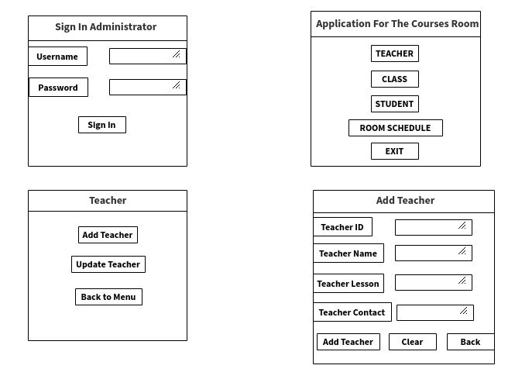

**DESIGN INTERFACE**

**System Process**:

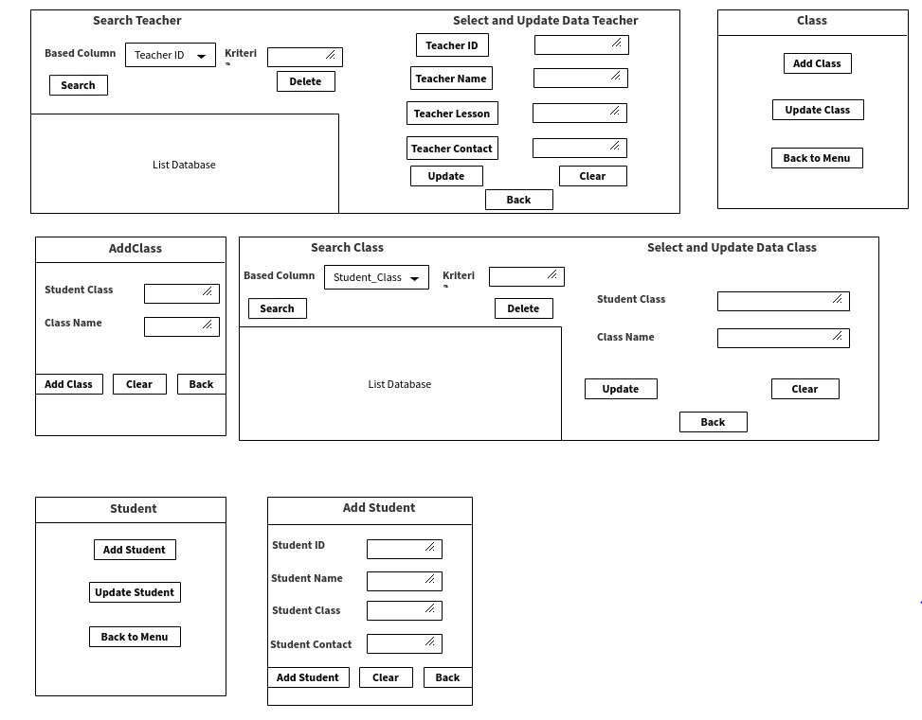

**DESIGN INTERFACE**

**System Process**:

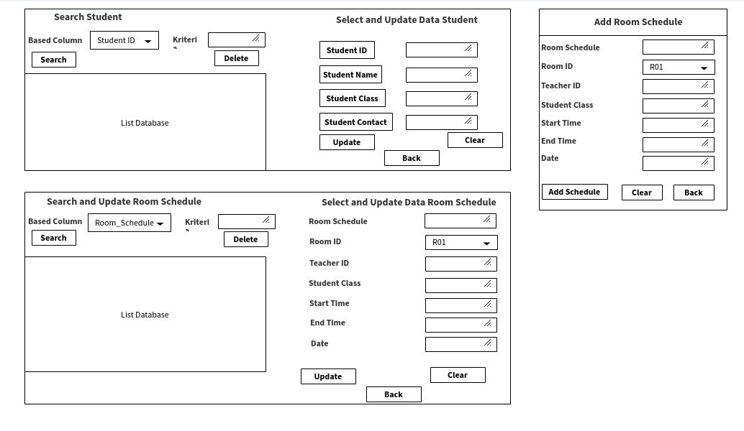

**DATABASE DESIGN**

**System Process**:

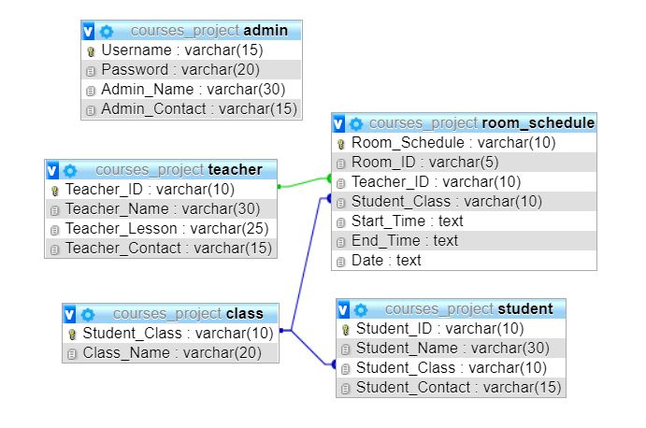

**TABEL DESIGN**

**System Process**:

|  |  |  |
| --- | --- | --- |
| **Tabel Admin** | | |
| **Nama Atribut** | **Tipe Data** | **Keterangan** |
| Username | Varchar(15) | PK |
| Password | Varchar(20) | null |
| Admin_Name | Varchar(30) | NULL |
| Admin_Contact | Varchar(15) | NULL |

|  |  |  |
| --- | --- | --- |
| **Tabel Teacher** | | |
| **Nama Atribut** | **Tipe Data** | **Keterangan** |
| Teacher_ID | Varchar(10) | Pk |
| Teacher_Name | Varchar(30) | null |
| Teacher_Lesson | Varchar(25) | null |
| Teacher_Contact | Varchar(15) | null |

|  |  |  |
| --- | --- | --- |
| **Tabel** **Room** **Schedule** | | |
| **Nama Atribut** | **Tipe Date** | **Keterangan** |
| Room_Schedule | Varchar(10) | Pk |
| Room_ID | Varchar(5) | null |
| Teacher_ID | Varchar(10) | Fk |
| Student_Class | Varchar(10) | Fk |
| Start_Time | text | null |
| End_Time | text | null |
| Date | text | null |

**TABEL DESIGN**

**System Process**:

|  |  |  |
| --- | --- | --- |
| **Tabel Class** | | |
| **Nama Atribut** | **Tipe Data** | **Keterangan** |
| Student_Class | Varchar(10) | Pk |
| Class_Name | Varchar(20) | null |

|  |  |  |
| --- | --- | --- |
| **Tabel Student** | | |
| **Nama Atribut** | **Tipe Data** | **Keterangan** |
| Student_ID | Varchar(10) | Pk |
| Student_Name | Varchar(30) | null |
| Student_Class | Varchar(10) | null |
| Student_Contact | Varchar(15) | null |

**DESIGN INTERFACE**

**System Process**:

|  |  |  |
| --- | --- | --- |
| **PROJECT FILE DETAILS** | | |
| **S.No** | **File Name** | **Remarks** |
| 1 | AddClass.java | Applications For The Courses Room contains method, JDBC SQL Syntax ,interface and etc. |
| 2 | AddRoomSchedule.java | Applications For The Courses Room contains method, JDBC SQL Syntax ,interface and etc. |
| 3 | AddStudent.java | Applications For The Courses Room contains method, JDBC SQL Syntax ,interface and etc. |
| 4 | AddTeacher.java | Applications For The Courses Room contains method, JDBC SQL Syntax ,interface and etc. |
| 5 | MainMenu.java | Applications For The Courses Room contains method, JDBC SQL Syntax ,interface and etc. |
| 6 | MenuClass.java | Applications For The Courses Room contains method, JDBC SQL Syntax ,interface and etc. |
| 7 | SearchUpdateStudent.java | Applications For The Courses Room contains method, JDBC SQL Syntax ,interface and etc. |
| 8 | RunMain.java | Applications For The Courses Room contains Main Method of the project. |

**Hardware :**

Asus x452e, Lenovo g41

**Operating System :**

Windows 7, Windows 10

**Software :**

Netbeans ide 8.2

**Editor :**

Adobe illustrator cc

Adobe photoshop cs 6

|  |  |  |
| --- | --- | --- |
| **PROJECT FILE DETAILS** | | |
| **S.No** | **File Name** | **Remarks** |
| 9 | MenuTeacher.java | Applications For The Courses Room contains method, JDBC SQL Syntax ,interface and etc. |
| 10 | MenuRoomSchedule.java | Applications For The Courses Room contains method, JDBC SQL Syntax ,interface and etc. |
| 11 | MenuStudent.java | Applications For The Courses Room contains method, JDBC SQL Syntax ,interface and etc. |
| 12 | SearchUpdateTeacher.java | Applications For The Courses Room contains method, JDBC SQL Syntax ,interface and etc. |
| 13 | SearchUpdateClass.java | Applications For The Courses Room contains method, JDBC SQL Syntax ,interface and etc. |
| 14 | SearchUpdateRoomSchedule.java | Applications For The Courses Room contains method, JDBC SQL Syntax ,interface and etc. |

**CONFIGURATION**